BIT 4107 – Mobile Application Development
ENHANCED PROFESSIONAL STUDENT LOGBOOK
STUDENT NAME: FAITH WANJA
ADMISSION NUMBER: BIT 2024/74102
SCHOOL/FACULTY: SCHOOL OF COMPUTING AND INFORMATICS
PROGRAMME: INFORMATION TECHNOLOGY
ACADEMIC YEAR: YEAR 3
SEMESTER: SEMESTER 2
LECTURER: MR NYORO
PHONE NUMBER: 0746505876

Table of Contents
BIT 4107 – Mobile Application Development 1
Week 1: Introduction to Mobile Application Development 3
1.1 Practical Activities Undertaken 3
1.2 Tools/Software Used 4
Week 2: Mobile Development Environment 4
2.0 Practical activities undertaken 4
2.1 SDK setup 4
2.2 Flutter project app set up 5
2.3 Emulator running 5
2.4 Creating First app 6
2.5 Changing font size, app title and background color 6
2.6 Tools used 6
2.7 Personal Reflection 7
Week 3: User Interface Design 7
3.1 Wireframes and mockups of student registration app 7
3.2 Wireframe to code implementation 8
3.3 Wireframes and mockups of e-commerce choice app 9
3.4 Wireframe to code implementation 11
3.5 Tools used 11
3.6 Personal reflection 11
Week 4: Event Handling and user interaction 12
4.1 Login Button click: 12
4.2 Register Button click: 12
4.3 Add to cart button: 12
4.4 Checkout button: 12
4.5 Tool used 15
4.6 Personal Reflection 16
Week 5: Data Management 16
5.1 Practical Activities Undertaken 16
5.2 Screenshots 16
5.3 Personal Reflection 19
WEEK 6: NETWORKING 19
6.1 API project creation 19
6.2 User directory loaded 21
6.3 RecyclerView dependency added 22
6.4 User model class created 22
6.5 Layout design 23
6.6 RecycleView Adapter created 24
6.7 Locally Generated record 24
6.8 Internet permission configured 25
6.9 Retrofit dependencies 27
6.10 API refining HTTP GET request 27
6.11 RetrofitClient configured 28
6.12 User data from a public REST API 29
Week 7: Application architecture 30
Data storage and database integration in mobile Applications 30
7.1 Activities undertaken 30
7.2 Database implementation 30
7.3 Personal reflection 31

Week 1: Introduction to Mobile Application Development
1.1 Practical Activities Undertaken
Learning about various Mobile app development tools.
Installing the tools.

1.2 Tools/Software Used
Android studio

VS code
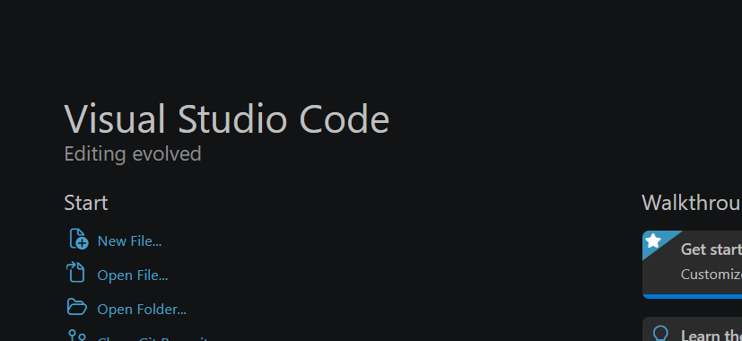

Week 2: Mobile Development Environment

2.0 Practical activities undertaken
Set up the development environment.

2.1 SDK setup
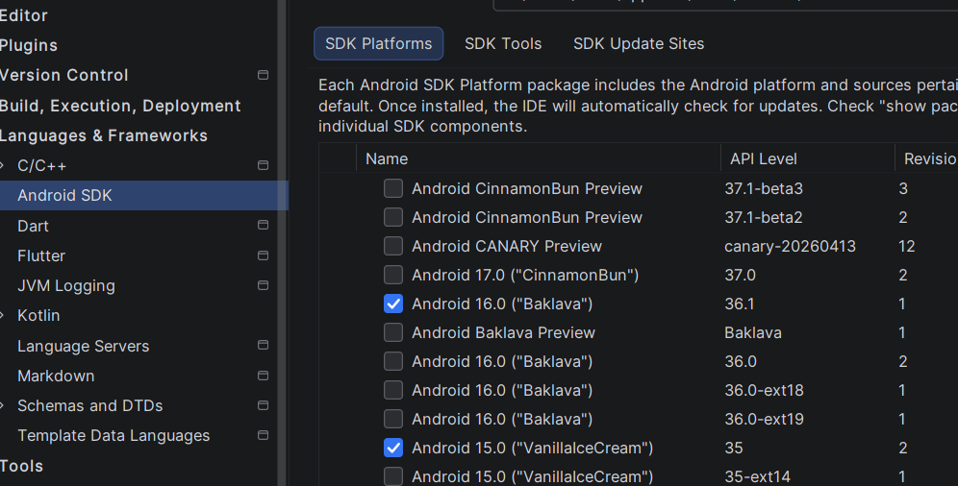

2.2 Flutter project app set up
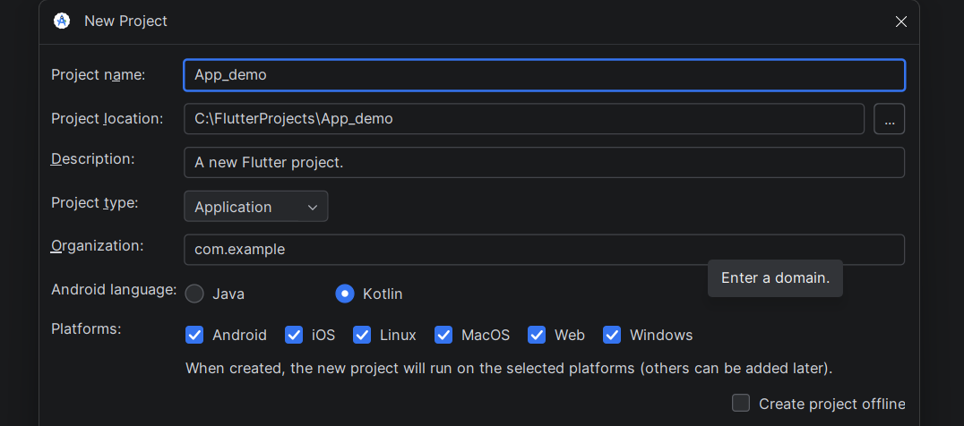

2.3 Emulator running
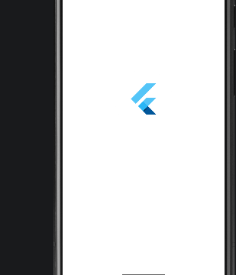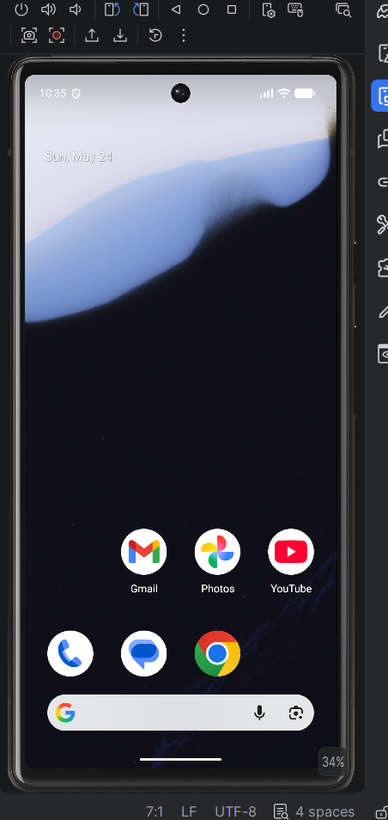

2.4 Creating First app
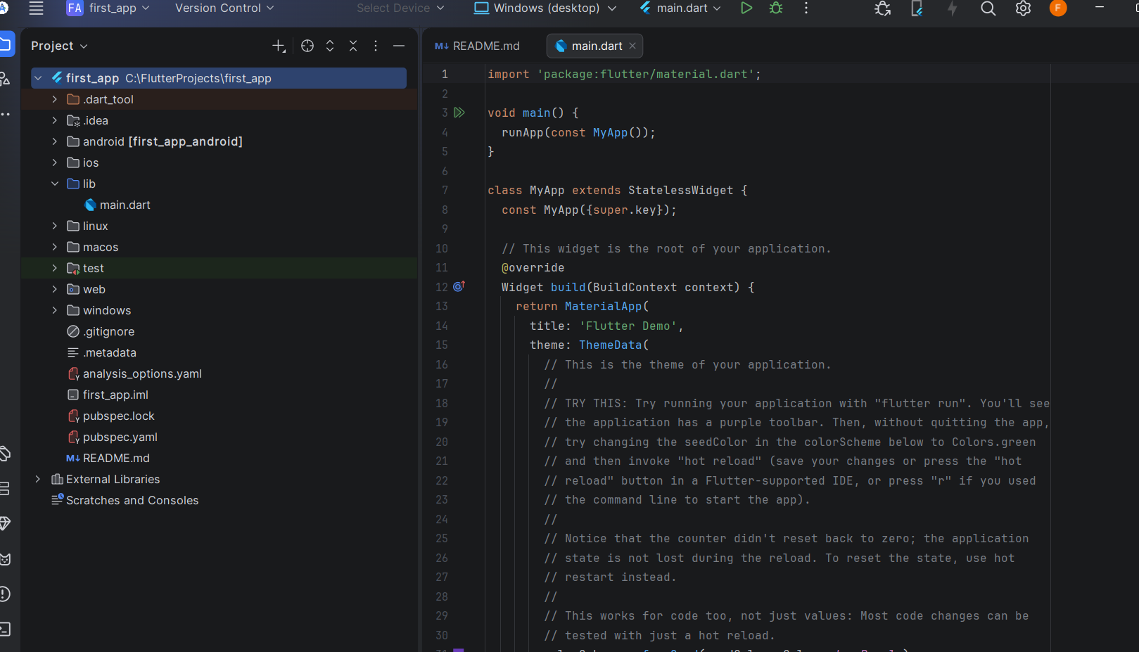

2.5 Changing font size, app title and background color
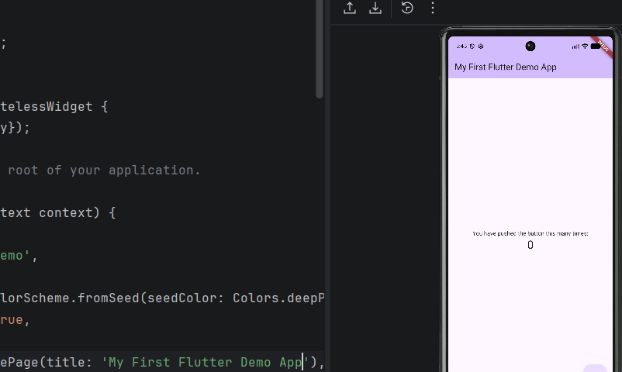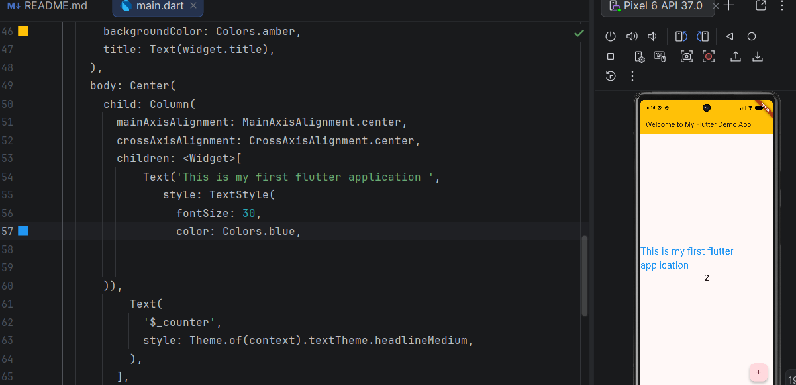

2.6 Tools used
Android studio

2.7 Personal Reflection
I learned how to set up Flutter development environment, create a new project and run applications. I gained practical experience in Flutter development by creating user interfaces, implementing navigation and applying programming concepts.

Week 3: User Interface Design

3.1 Wireframes and mockups of student registration app
Designed application wireframes using Figma. Created login, registration and dashboard screen prototypes of the student management App.
a) Wireframe of a login screen:
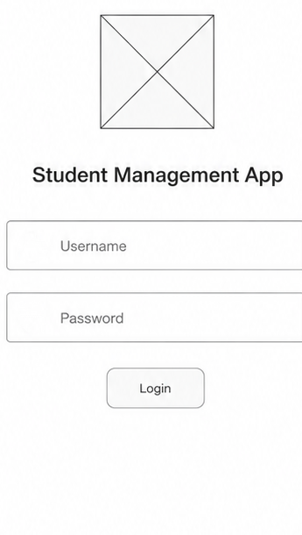

b) Wireframe of a registration screen
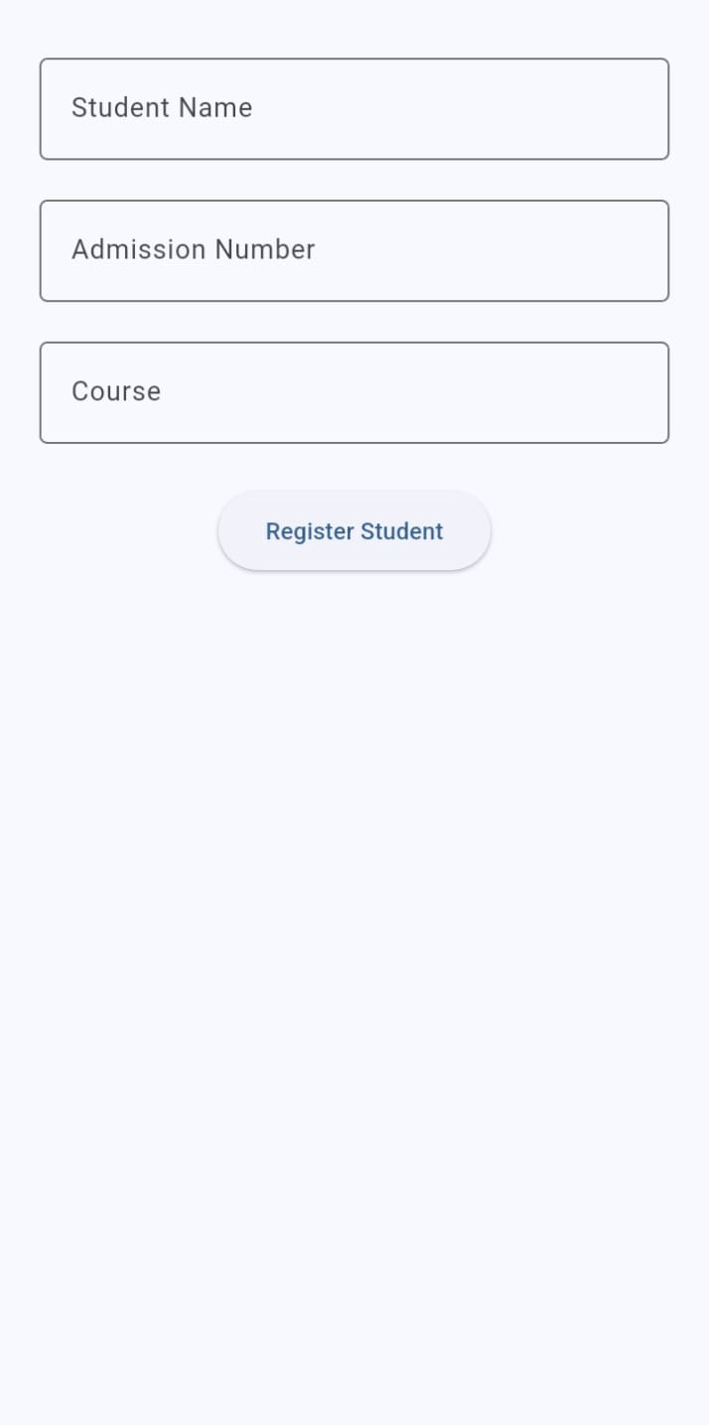
c) Students’ dashboard
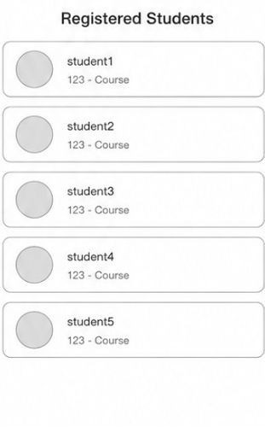

3.2 Wireframe to code implementation
Fig 1: 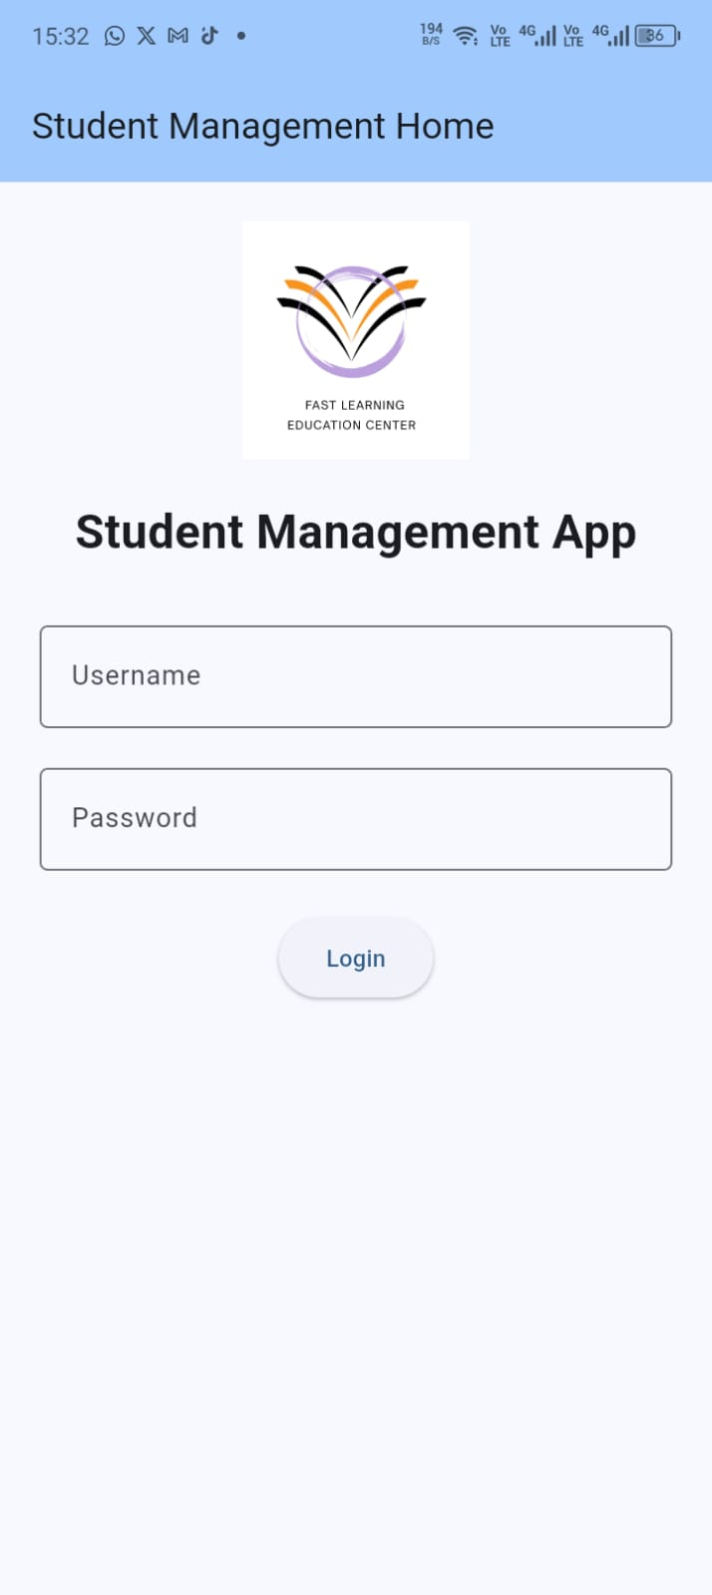 Fig 2: 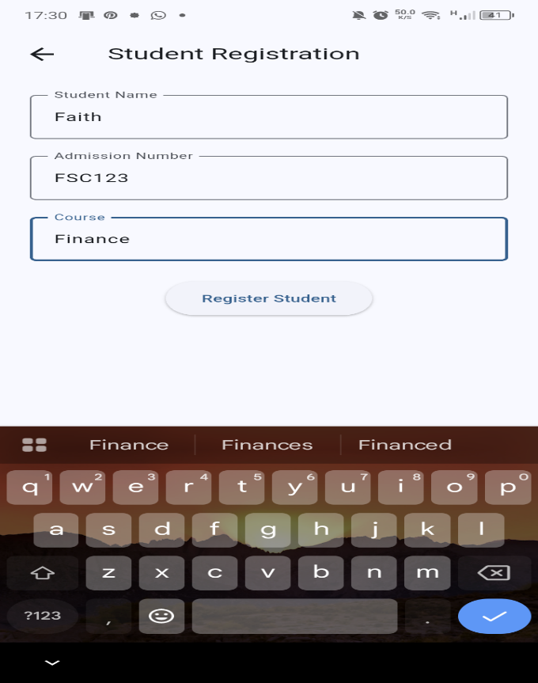 Fig3: 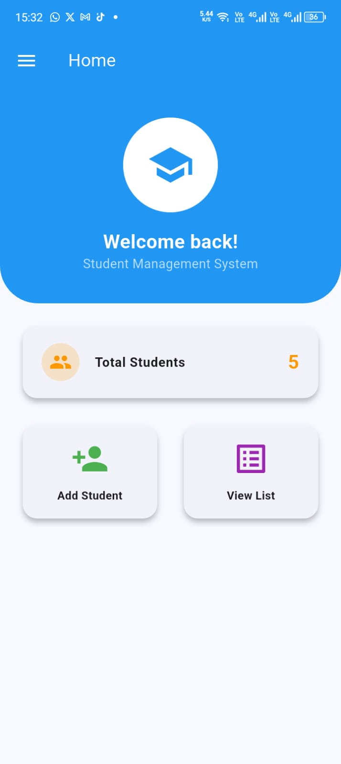
Fig 4: 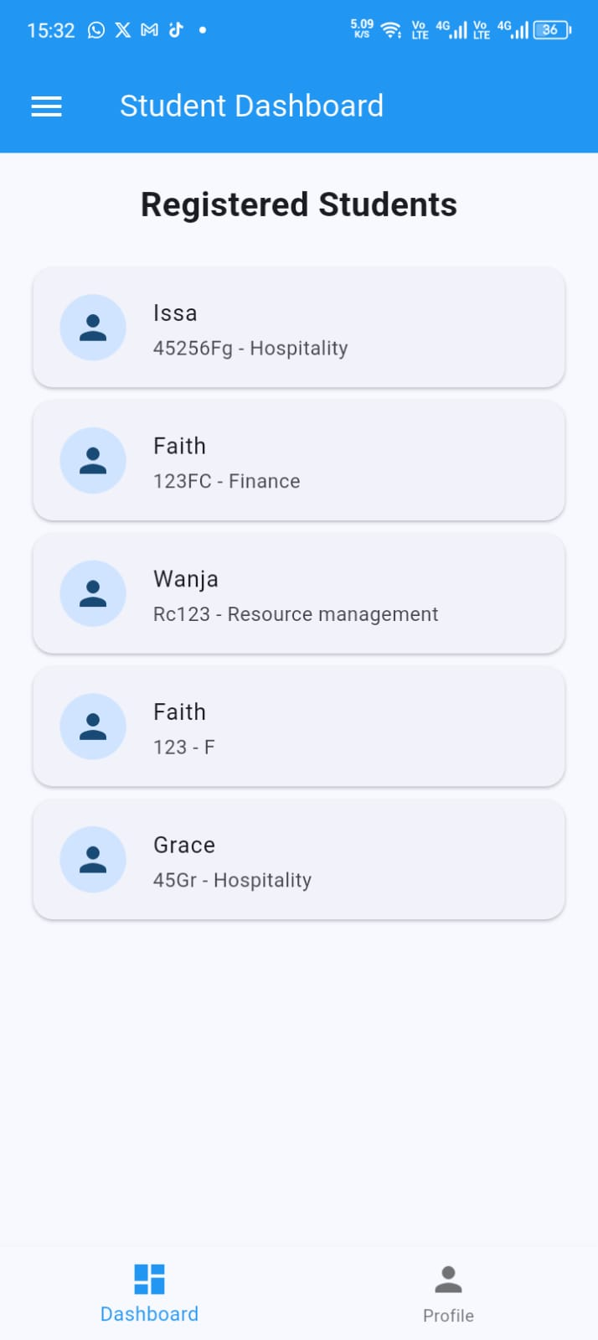 Fig 5: 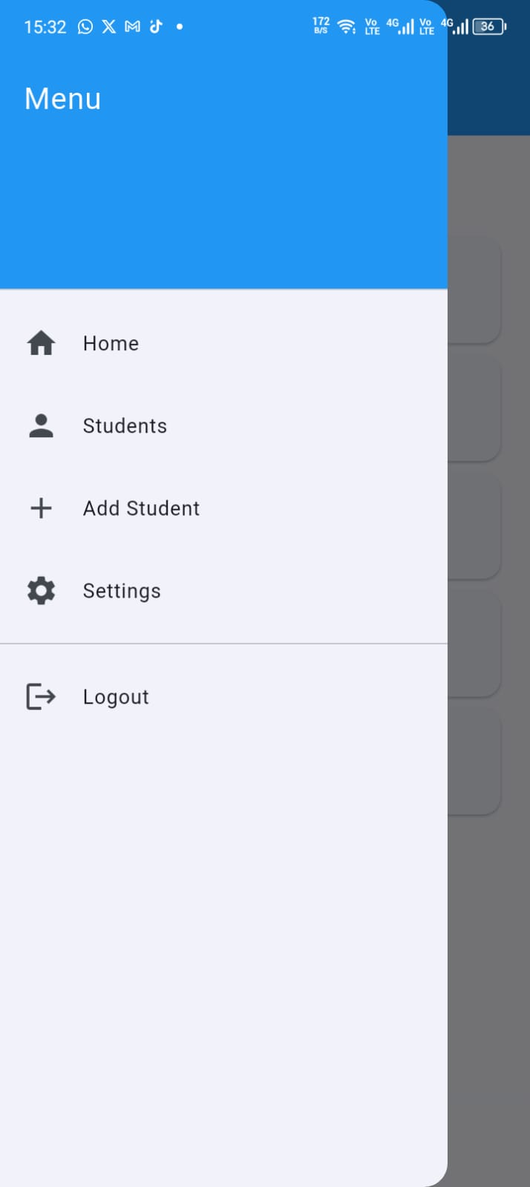

3.3 Wireframes and mockups of e-commerce choice app
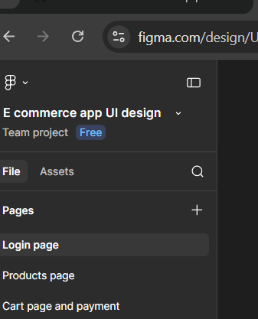
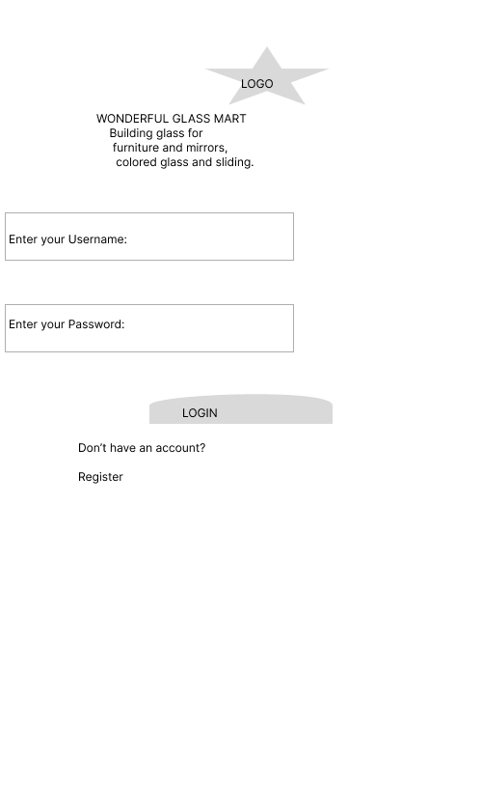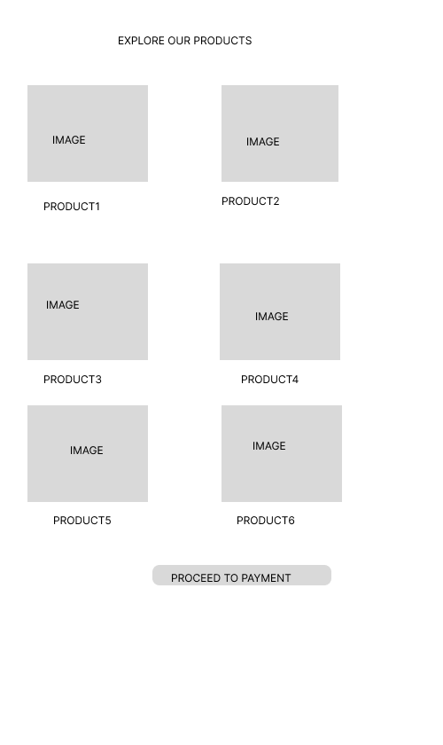
a) Login screen b) Products screen

3.4 Wireframe to code implementation
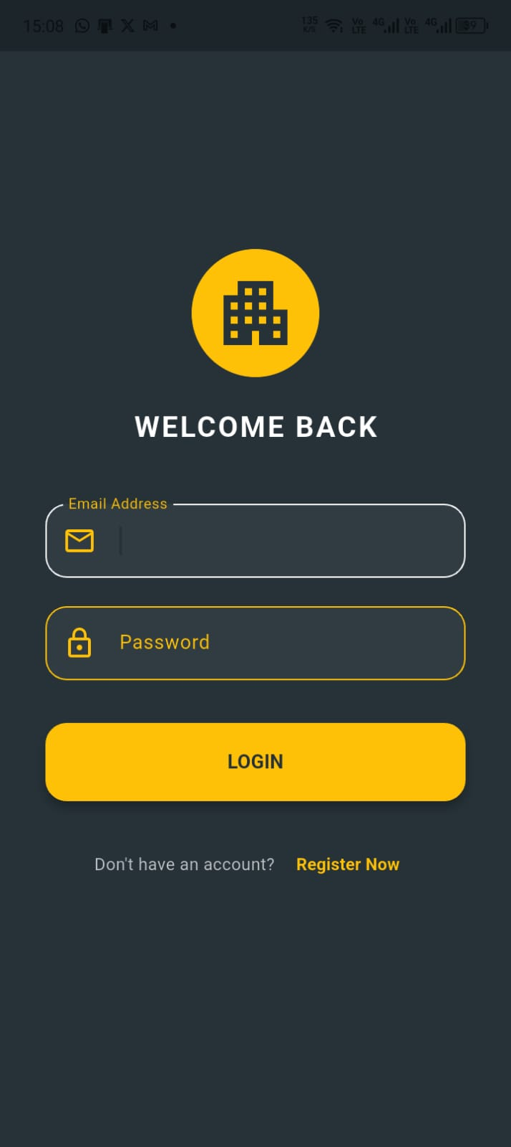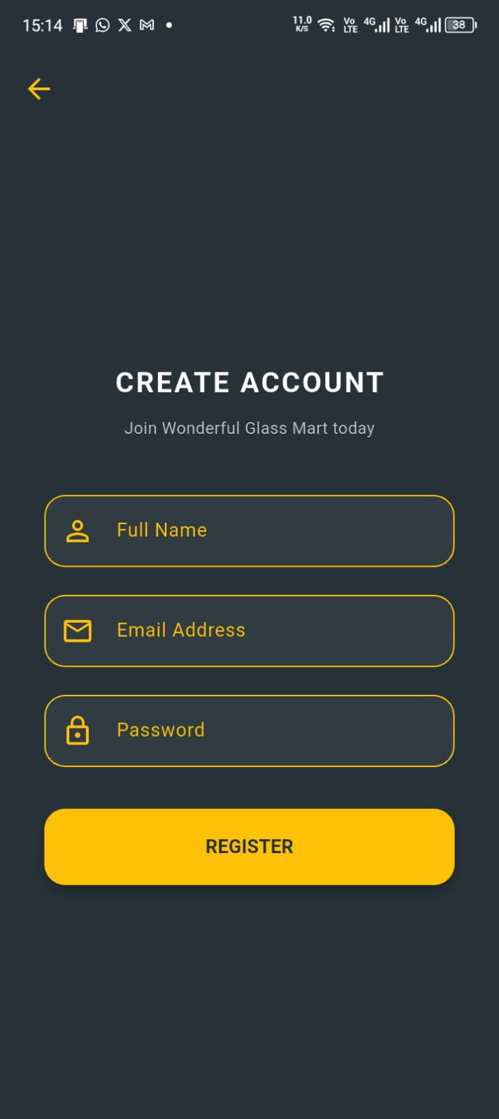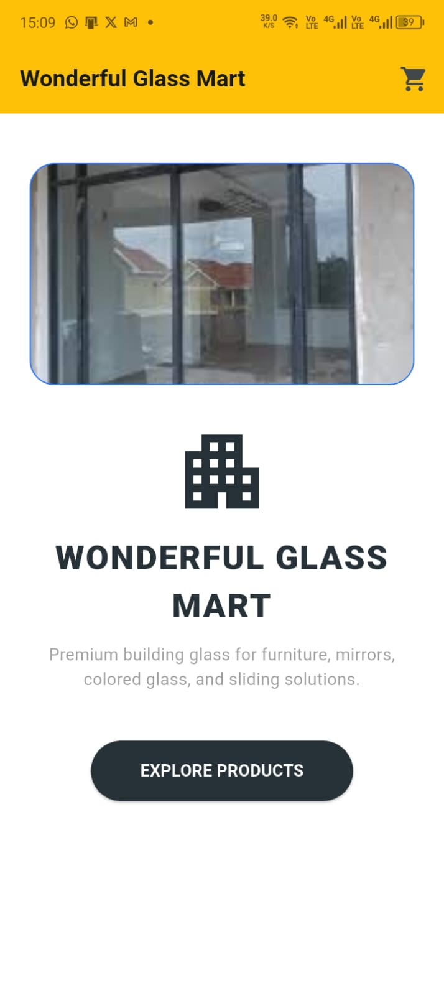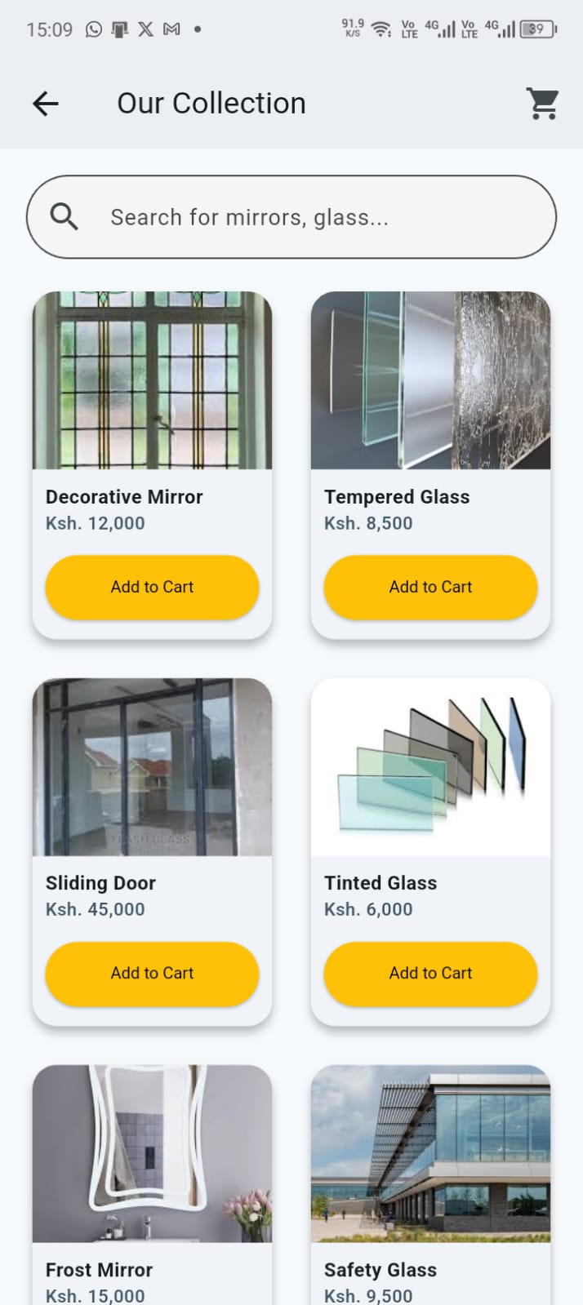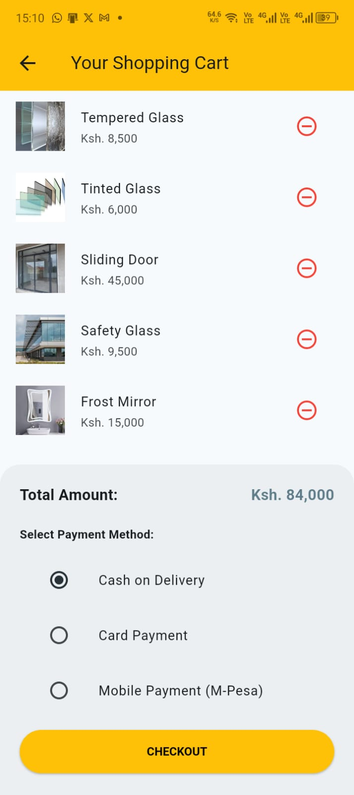

3.5 Tools used
Figma for design
Android studio for app

3.6 Personal reflection
The screen prototypes in Figma were implemented in Flutter using widgets such as TextField, ElevatedButton, Image, Column and scaffold. The implemented screen closely followed the layout and structure defined in wireframes. This practical enhanced my skills in mobile application development by combining user interface design, Flutter Programming and navigation to build functional apps.

Week 4: Event Handling and user interaction

4.1 Login Button click:
Validates input. Navigates to products screen.

4.2 Register Button click:
Saves user to SQLite.

4.3 Add to cart button:
Adds products to cart list

4.4 Checkout button:
Calculates total amount. Shows a success message.
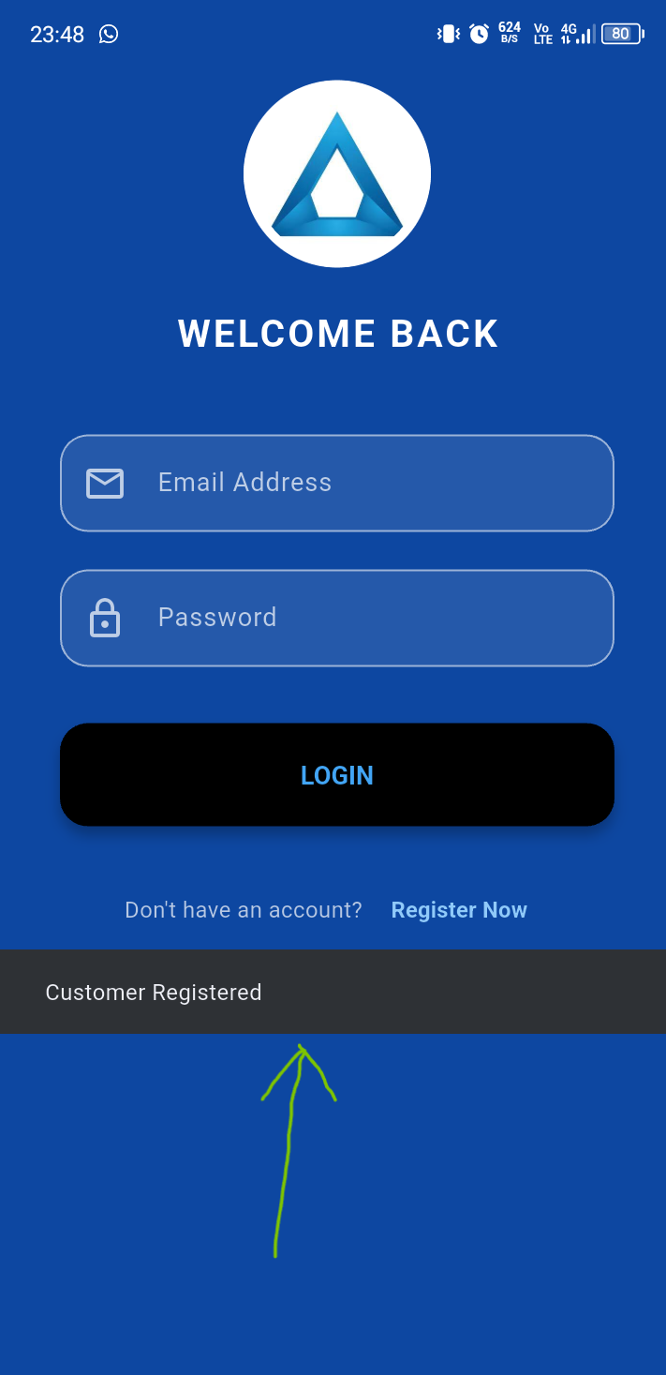

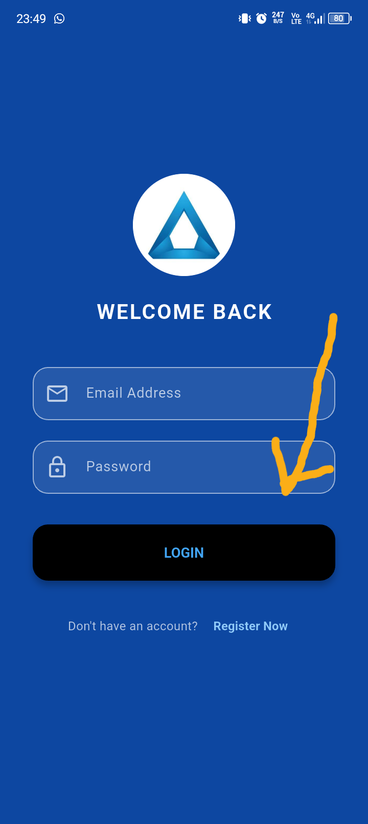

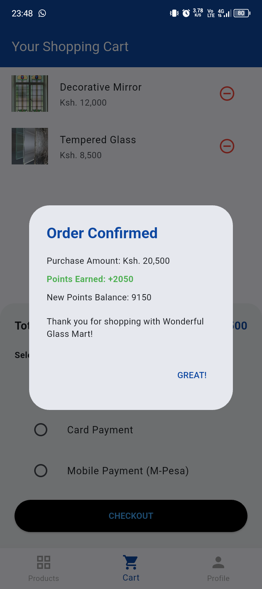

4.5 Tool used
Android Studio

4.6 Personal Reflection
I gained practical experience in handling user interaction within a flutter application, that is, how button events, navigation and form validation work together to improve user experience.

Week 5: Data Management

5.1 Practical Activities Undertaken
Implemented local data storage using SharedPreferences and SQLite. Stored login information and uservsession using SharedPreferences and designed SQLite database to store customer records and implemented CRUD.

5.2 Screenshots
1. 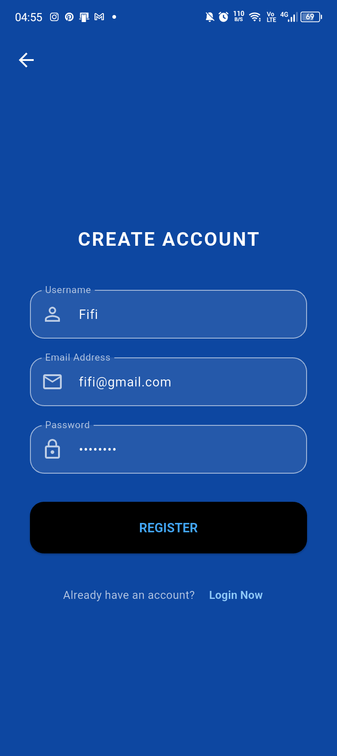 2. 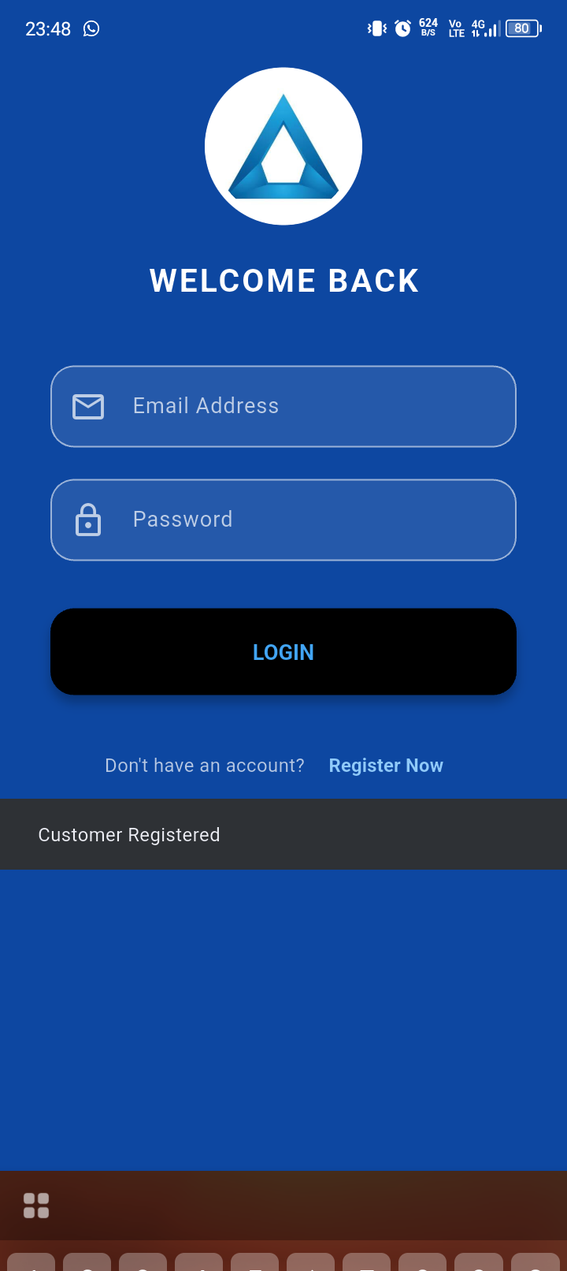
3. 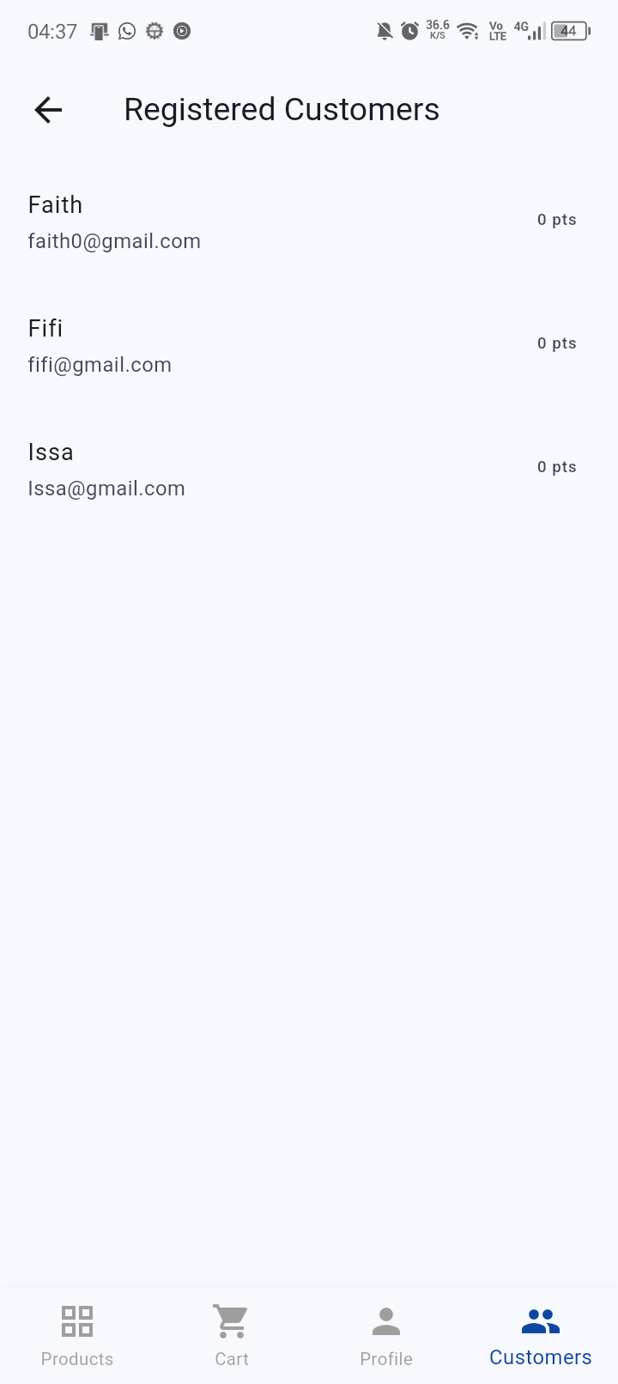 4. 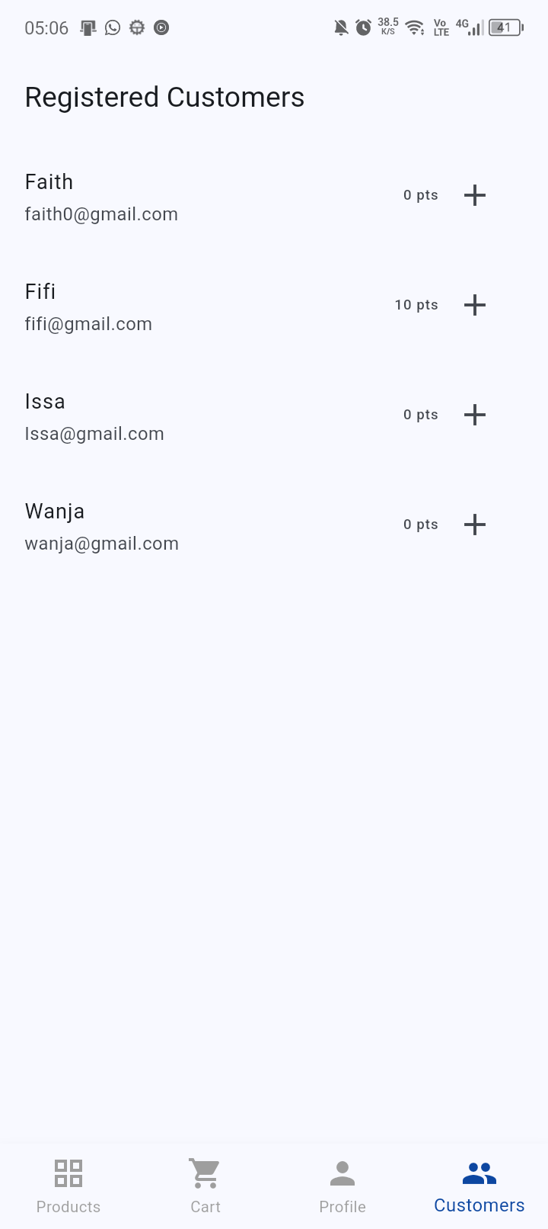
5. 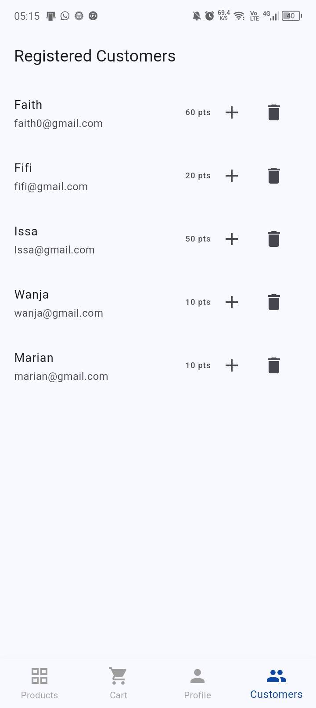 6. 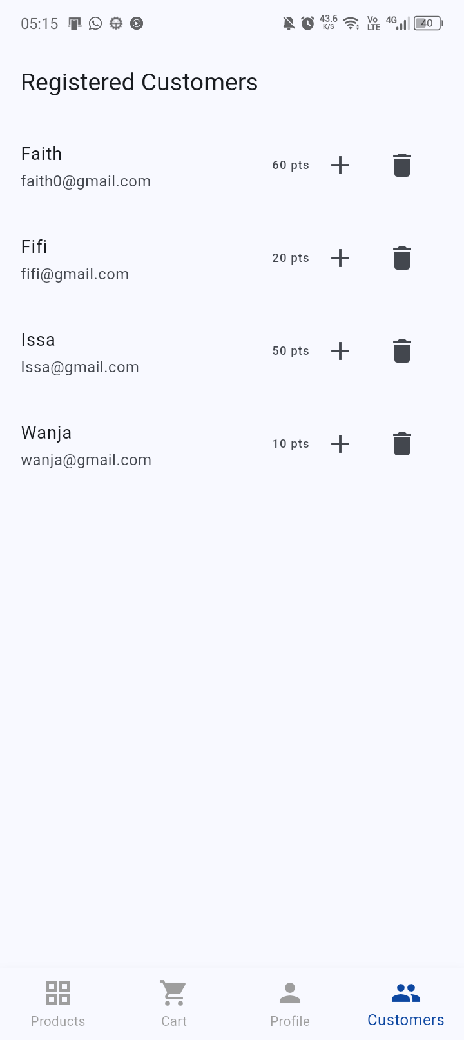
7. 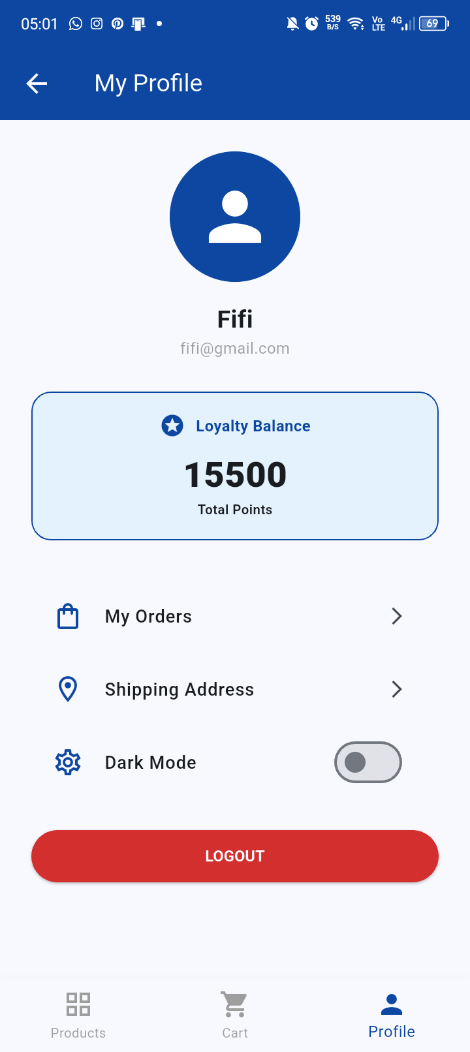

5.3 Personal Reflection
Learned how local data storage improves functionality by preserving user information and reducing dependency on network connections by the users.

WEEK 6: NETWORKING

6.1 API project creation
Applications ran successfully



6.2 User directory loaded


6.3 RecyclerView dependency added
Implementation(“androidx.recyclerview: recyclerview:1.3.2”)

6.4 User model class created
Created in java module.

6.5 Layout design
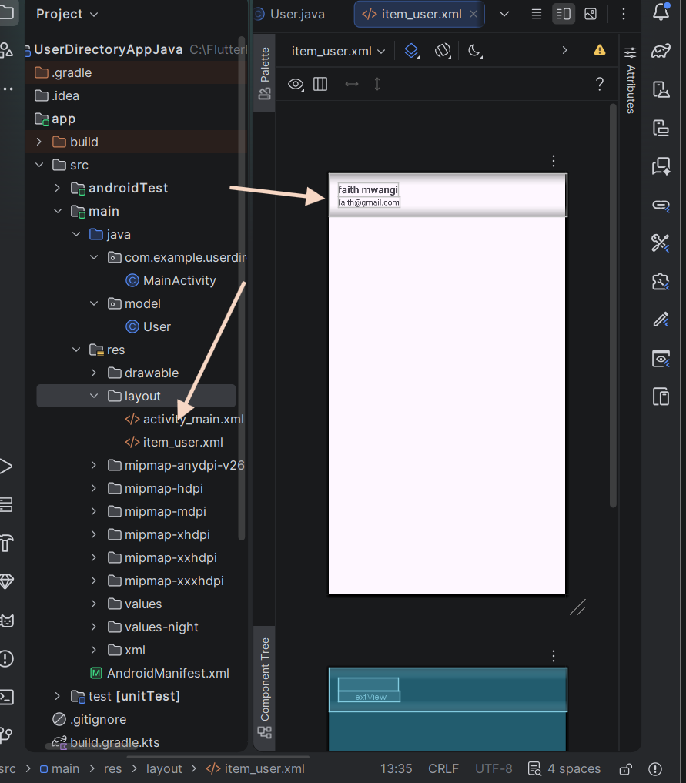

6.6 RecycleView Adapter created
Created inside the model class created.

6.7 Locally Generated record
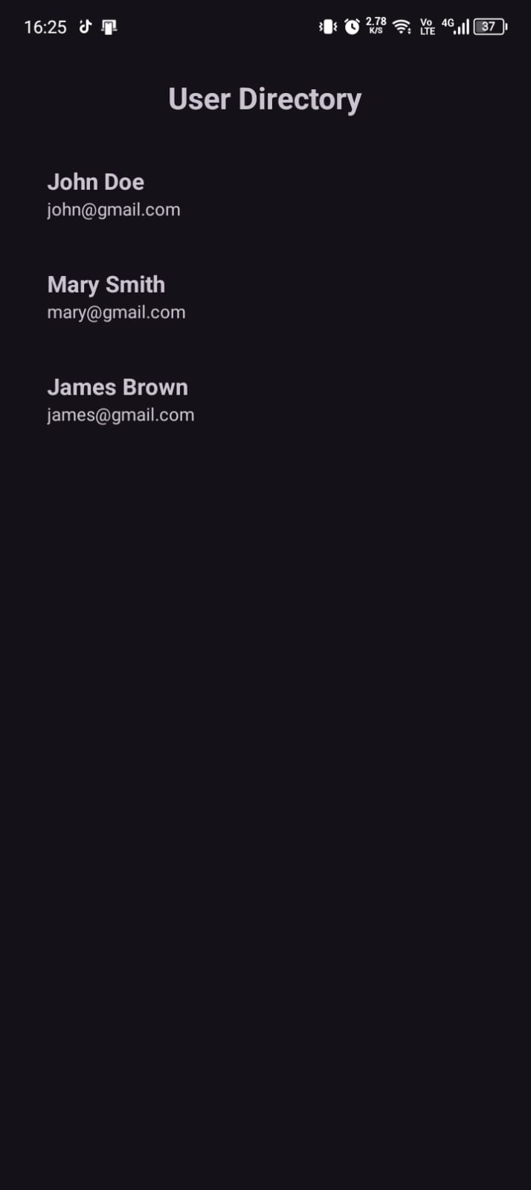

6.8 Internet permission configured
For network connection to the API.
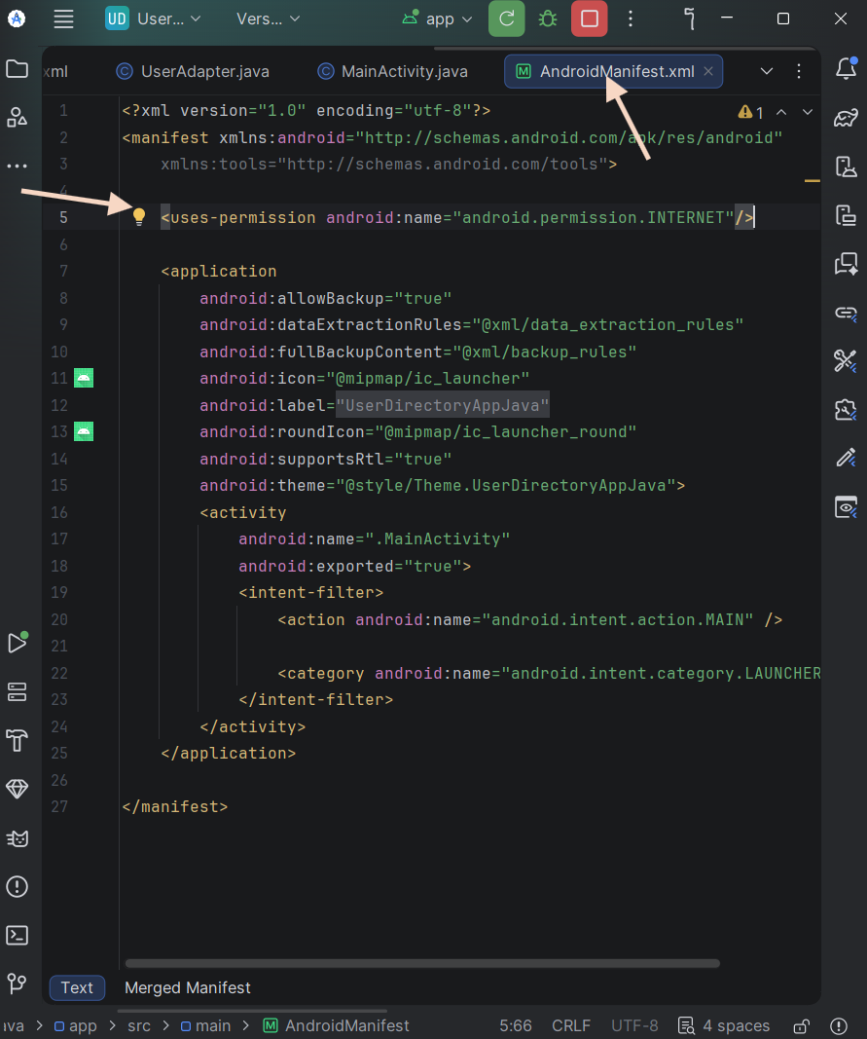

6.9 Retrofit dependencies
Implementation(“com.squareup.retrofit2: retrofit:retrofit:2.11.0”)
Implementation(“com.squareup.retrofit2: converter-gson:2.11.0”)

6.10 API refining HTTP GET request
Using the getter methods.

6.11 RetrofitClient configured
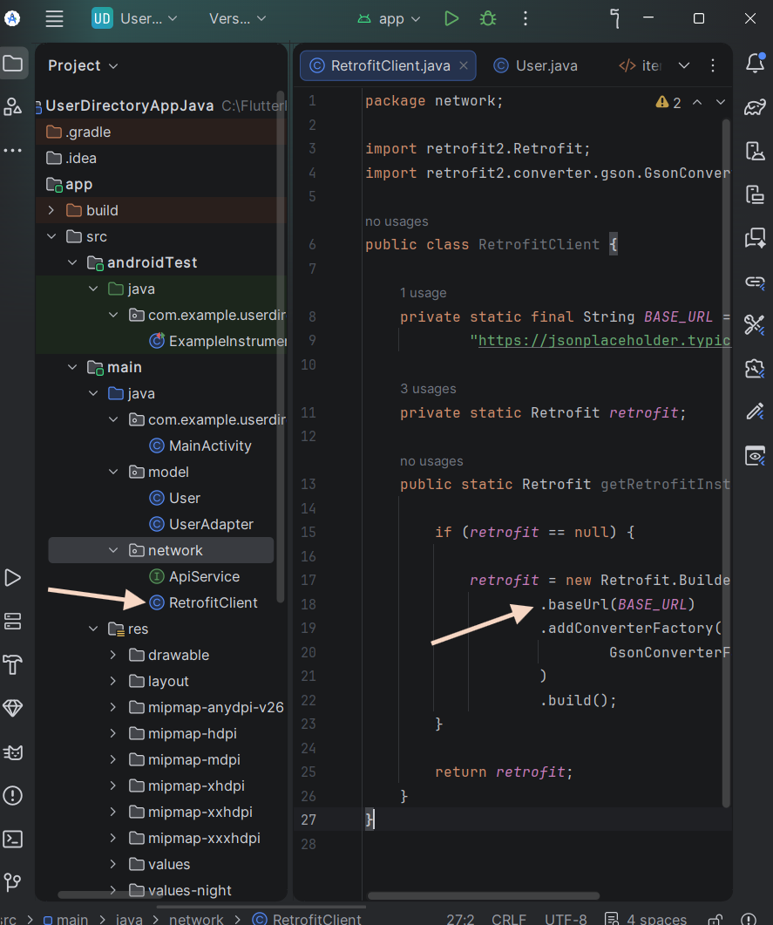

6.12 User data from a public REST API
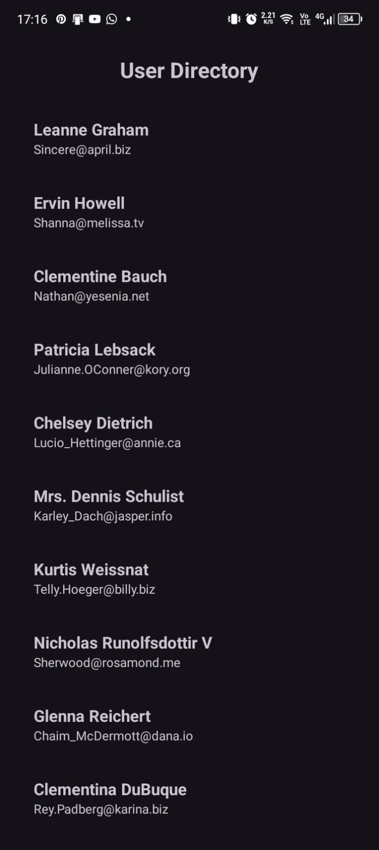

Week 7: Application architecture

Data storage and database integration in mobile Applications

7.1 Activities undertaken
Implemented shared preferences to prevent user from logging in every time they open the app. Stored images in the application. Used SQLite to store the users registered. Implemented CRUD. Implemented Firebase for the real time database.

7.2 Database implementation
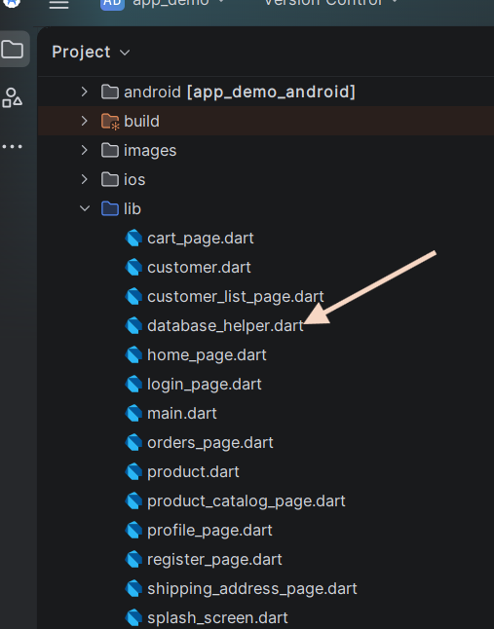

7.3 Normalization
Unnormalized:
Product_Id | Product_Name | Customer_Name1 | Customer_Name2
P001 | Frosted Glass | Fifi | Wan
P002 | Table Glass | Marian | Sifwa
1NF:
Product_Id | Product_Name | Customer_Name
P001 | Frosted Glass | Fifi
P001 | Frosted Glass | Wan
P002 | Table Glass | Marian
P002 | Table Glass | Sifwa

2NF:
(Products Table)
Product_Id | Product_Name
P001 | Frosted Glass
P002 | Table Glass

(Customers Table)
Product_Id | Customer_Name
P001 | Fifi
P001 | Wan
P002 | Marian
P002 | Sifwa

7.4 Personal reflection
Gained experience in implementing databases in a mobile application.

